

**Course name: Introduction to Business Finance**

**Name: Syeda Sheeza Fatima**

**Student ID: 20202-27222**

**TERM REPORT:**

***Gul Ahmed Textile Mills:***

**Background:**

Gul Ahmed Textiles was founded back in 1 April 1953, and has its headquarters in Karachi, Pakistan. The history of subcontinental textiles is the history of Gul Ahmed. Gul Ahmed considered as one of the pioneers in textile industry. The group started trading in textiles in the early 1900s. The group entered the manufacturing industry in 1953 with the establishment of its iconic name, Gul Ahmed Textile Mills Ltd and incorporated as a privately limited company Ever since being listed on the Karachi Stock Exchange in 1970; the company has developed rapidly and holds a prominent position in the textile industry. It expanded to retail sector and founded ideas by Gul Ahmed back in 2003.

It’s the combine unit making each n everything from cotton yarn to finished products. Gul Ahmed not only doing well as a company but also believes in protecting the environment. In order to treat its wastes appropriately, It has also set up waste water treatment plant to treat 100% of its effluent, bringing it to NEQS level.

Not only it is playing an essential role as a textile giant but also has its prominent presence in retail industry.

**The company:**

Gul Ahmed Textile Mills limited, together with its subsidiaries, manufactures, sells, trades in, and exports textile products. It operates through four segments: Spinning, weaving; Retail and distribution; and processing, home textile and apparel

Not only it is playing an essential role as a textile giant but also has its prominent presence in retail industry. When it comes to its retail industry, the Company engages in manufacturing and selling the clothing through its retail chain under the name of Ideas by Gul Ahmed.

Not only it’s offering the home accessories which include bedding, cushions and bath items but also the fashion clothing such as prêt wear, unstitched fabrics for (Women and Men), formal and semi formal and casual wear both for women and men.

It includes Gul Ahmed Textile Mills, Gul Ahmed Energy and Habib Metropolitan Bank. More recently, a chain of retail outlets has been operating under the name of ideas by Gul Ahmed. Opening of ideas of Gul Ahmed marked its first entry into retail business. It all began from Karachi now there are 40 retail stores across all over the country.

**Basic philosophy:**

* At Gul Ahmed, we constantly strive to challenges the limitations of all the possibilities when it comes to weaving, printing, embroidery & embellishments.
* The cloth used isn’t merely for fabric, they treat it like the way artist treats it’s canvas, with love, respect, and dedication it deserves
* Gul Ahmed understands that style and fashion plays a great role in our lives so they strive to bring it to your doorstep in the most effortless way.
* Gul Ahmed’s motto focuses on providing excellent quality and service

***MISSION STATEMENT:***

* ***To Deliver value to our stakeholders through innovative technologies, teamwork and by fulfilling our social and environmental responsibilities***

***VISION STATEMENT:***

* ***Enriching Lives by Inspiring Change.***

***Core Values:***

* Integrity
* Passion
* Teamwork
* Creativity
* Quality

Direct competitors:

* Sapphire Textiles.
* Nishat industries (Nishat linen)
* Sana safinaz
* Khaddi
* Bonanza satrungi
* Motifz

Indirect competitors:

* Outfitters
* *Splash*
* *Breakout*
* *Levis*
* *Stoneage*

***Founder:***Mr Haji Bashir Ali Mohammad

***Board of directors:***

* Mr Mohamed Bashir (Chairman)
* Mr Zain Bashir (Vice Chairman/Executive Director)
* Mr Mohammed Zaki Bashir (Chief Executive Officer)
* [Mr. Ziad Bashir](javascript:void();)Mr. Ziad Bashir (Non-Executive Director)
* Dr Amjad Waheed (Non-Executive Director)
* Mr Ehsan A. Malik (Independent Non-Executive Director)
* Ms Zeeba Ansar (Independent Non-Executive Director)

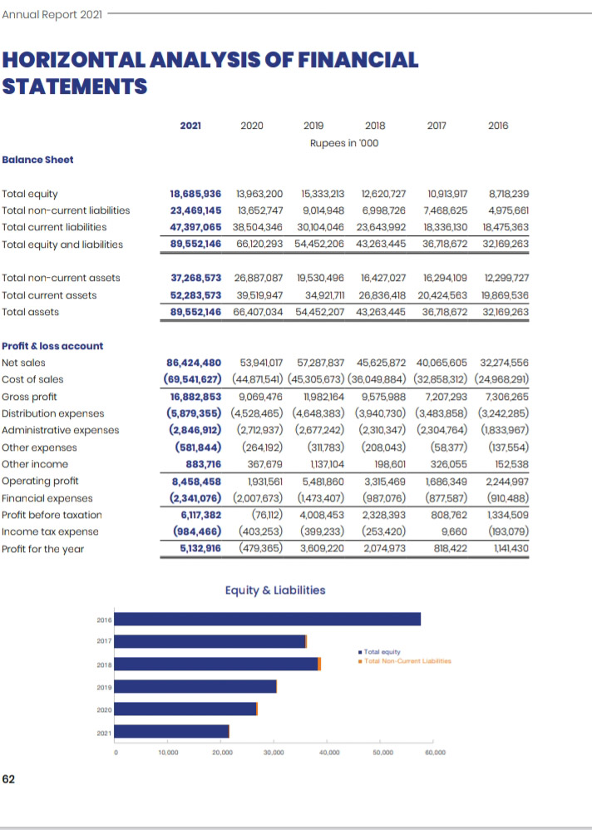

Common sized

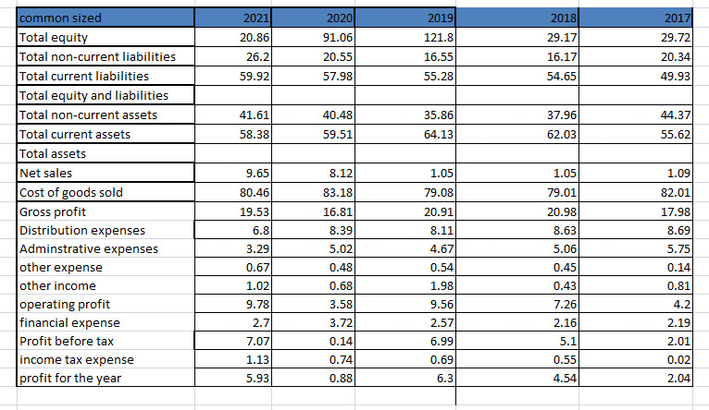

**Common Sized: (INTERPRETATION)**

* The common size analysis shows that the during the five years current assets have increased mainly due to the increase in the level of inventory, trade debtors and refunds from the government.
* Non-current Assets including property, plant and equipment, intangible assets and long term investments reflected an increase as compared to prior year. The increase attributed to investment in property plant and equipment as well as in worldwide developers (private limited) subsidiaries to the extent of 54.84%.
* Looking at the portion of liabilities, current liabilities went up by Rs. 8.48 billion i.e. 21.80% as compared to 2020 and are at the highest level over the 5 years. Mainly, the increase occurred as a result of short term borrowings, followed by increase in trade creditors and current maturity of long term borrowings. The Increased in commercial borrowings due to higher credit sales of yarn and additional inventory for enhanced spinning capacity.
* Apart from this, there’s also an increase in non-current liabilities as a result of increased long term loans which benefited the company many folds, including but not too limited to enhanced capacity, the latest technology, operational excellence and remarkable improvement in top and bottom lines.
* Deferred liabilities including deferred taxation and staff retirement has decreased due to tax credits up to 2020.
* Export sales have gone up due to change in Pkr/Dollar parity and management's decision to tap into new markets and concentrate on profitable orders while local sales have also increased due to reduced covid restrictions.
* Over the five years, the sales have increased by 168% i.e. by Rs 54.15 billion.  Sales in the current year have increased by 60% while gross profit margin has also increased to 19.53% from 16.79% in last year.
* Gross profit margin would have been higher but restricted due to some reasons.
* The highest increase in company’s profit before tax primarily as a result of additional spinning capacities coming online major BMR in weaving setup, replacement of inefficient machinery in processing and revised smart stitching plans.
* Total equity of the company shows the fluctuations over the five years however it shows a little increase in between years of 2017 and 2019 but sharply decreased in 2021.

**Indexed analysis:**

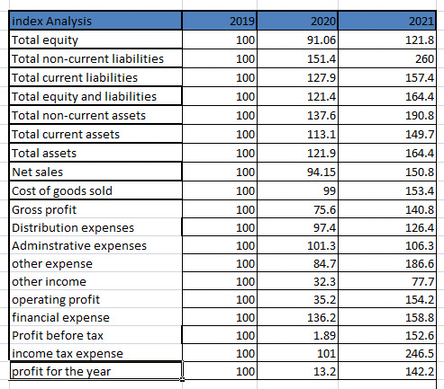

**Index Analysis: Interpretation**

For Gul Ahmed Textile Mills, the base year is 2016 and all financial statement items are 100.0 percent for that year. Index analysis shows the same picture, total current and non currents assets have increased and show the drastic increase between the year of 2020 and 2021. The total current and noncurrent liabilities are at the highest level over the 5 years at year 2021. Sales have also gone up in the year 2021 as compared to year 2020 due to ease of covid restrictions. However it could’ve been higher but due to an extended period of lockdown it didn’t take place. Gross profit margin has also slightly increased in 2021 as compared to 2020.  Profit before tax and profit for the year shows the drastic change in the year 2021 as compared to past 5 years. The reasons are mentioned above in common size. Total shareholder’s equity of company has also increased in the year 2021 by 4.7 billion as compared to prior years due to the turnaround sales volume/value and profitability. At June 2021, total equity was around 18.69 billion which indicates there’s growth of around 114% over the last five years. There’s also increased in reserves in current year due to higher profit earned.

**FINANCIAL RATIOS:**

|  |  |  |  |  |  |
| --- | --- | --- | --- | --- | --- |
| Financial ratio: | 2021 | 2020 | 2019 | 2018 | 2017 |
| Profitability ratio |  |  |  |  |  |
| Gross profit ratio | 19.53 | 16.81 | 20.92 | 20.99 | 17.99 |
| Operating profit margin | 9.78 | 3.58 | 9.56 | 7.26 | 4.20 |
| Net income margin | 5.94 | 0.89 | 6.30 | 4.55 | 2.04 |
| Return on Assets or investment. | 5.73 | 0.72 | 6.62 | 4.79 | 2.22 |
| Return on Equity | 27.45 | 3.43 | 23.53 | 16.44 | 7.49 |
| Asset utilization Ratios: |  |  |  |  |  |
| Accounts Receivable Turnover: | 35.53 | 113.1 | 103.5 | 128.1 | 60.0 |
| Asset collection period | 1.98 | 3.18 | 3.47 | 5.99 | 21.6 |

**There are some huge fluctuations in profitability ratios peaking in year 2019 slightly increasing and decreasing in 2021**

|  |  |  |  |  |  |
| --- | --- | --- | --- | --- | --- |
| Liquidity ratio: | 2021 | 2020 | 2019 | 2018 | 2017 |
| Current ratio | 1.10 | 1.02 | 1.16 | 1.13 | 1.11 |
| Quick/acid ratio | 1.02 | 0.91 | 0.98 | 0.97 | 1.03 |
| Net working capital | 4,886,508 | 1,015,601 | 4,817,665 | 3,192,426 | 2,088,433 |

**The liquidity ratios are fluctuating like increase and decrease in between the years of 2017 and 2020 and increased by 2021**

|  |  |  |  |  |  |
| --- | --- | --- | --- | --- | --- |
| Market value ratio | 2021 | 2020 | 2019 | 2018 | 2017 |
| Earning per ratio | 10.00 | 1.12 | 10.12 | 5.82 | 2.50 |
| Price to earnings ratio | 4.80 | 42.9 | 4.74 | 8.25 | 19.22 |

**Market value ratio remains fluctuated but there’s increased in earning per share and sharp decrease in price to earnings ratio.**

|  |  |  |  |  |  |
| --- | --- | --- | --- | --- | --- |
| Leverage ratio | 2021 | 2020 | 2019 | 2018 | 2017 |
| Debit ratio | 0.79 | 0.78 | 0.71 | 0.88 | 0.49 |
| Time interest earned | 3.61 | 0.96 | 3.72 | 3.36 | 1.92 |

**All the leverage ratios increased by 2021**

|  |  |  |  |  |  |
| --- | --- | --- | --- | --- | --- |
| Turnover ratio | 2021 | 2020 | 2019 | 2018 | 2017 |
| Inventory turnover | 22.31 | 12.09 | 10.96 | 12.41 | 28.94 |
| Fixed Asset Turnover | 2.31 | 2.00 | 2.93 | 2.77 | 2.45 |
| Total Assets Turnover | 0.97 | 0.81 | 1.05 | 1.05 | 1.09 |
| Total current asset turnover | 1.65 | 1.36 | 1.64 | 1.70 | 1.96 |

**The turnover ratios remain constant and increased significantly**

**INDUSTRY AVERAGES:**

Industry average: For the year of 2019

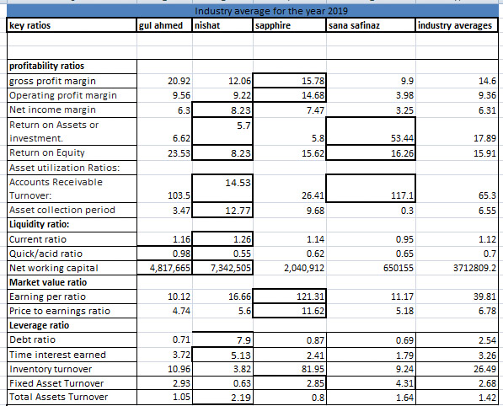

Liquidity ratios

* **Current** **ratio**: The average current ratio is 1.12 which is high. This shows that all the companies are well liquid but Nishat and Gul Ahmed they’re highly liquid, that shows they’ve too much assets that are to be utilized efficiently. The rest of the two have a current ratio below the industry average which could be taken as a good view as they don’t have extra current assets.
* **Quick**/**acid** **ratio**: the industry average shows all the companies have high quick ratio which makes them highly liquid, however too high ratio indicates inefficient use of current assets. As Gul Ahmed tends to be most liquid, it also shows inefficiency in current assets.
* **Net working capital:**

The industry average is around 3.8. Nishat has the highest net working capital which means company has too much net working capital and it isn’t using its assets and liabilities efficiently, While Sana safinaz has the least net working capital.

* **Accounts** **Receivables** **turnover**: Higher the receivables the more the company is efficient when it comes to collecting debts. The average receivables turnover of this industry is 65.3. Sana safinaz has the highest turnover which means it’s most efficient in collecting debts; Gul Ahmed is also performing above the industry average as well. Nishat and sapphire has the least efficient in collecting its debts as their receivables turnover is far less than industry average. Both of these firms need to take strict action towards credit control management.
* **Asset collection period:**

The lower the asset collection period, the faster the organization is when it comes to collecting payments. Nishat has the highest Asset collection period which isn’t the good sign as they’re low in terms of collecting payments while the Sana safinaz has the lowest collection period which means they’re the fastest to collect the payments. Rest of the firms should decide to grant more credit in order to increase the sales.

**Leverage ratio:**

* **Debt** **ratio**: the Nishat has the highest debt ratio while the other two including Gul Ahmed and sapphire have the lowest ratio. Sana safinaz has the worst debt ratio.
* **Time interest earned:**

It indicates how many times a firm can pay interest with its EBIT. The average industry ratio is around 3.26 which mean Nishat has the highest time interest earned ratio which means it can make interest payments 5.13 times from its EBIT. Gul Ahmed’s ratio is slightly above the industry average which is good. Sana safinaz and Sapphire are performing below the industry average which means they need to take certain steps like increasing sales and reducing costs should be taken to remain competitive.

**Profitability ratios:**

* **Gross profit margin:**

The average gross profit margin is 14.6. Gul Ahmed has the highest Gross profit margin. Sana safinaz has the least one. Sapphire has the higher profitability margin above the industry average. While Sana safinaz and Nishat has to take certain steps such as improving their sales and reducing cost of goods sold in order to reach the average Gross profit margin

* **Operating profit margin:**

Sapphire has the highest operating profit margin of around 14.68 which is over the average operating profit of 9.36. Rest of the companies Nishat, Gul ahmed, Sana safinaz are performing below the industry average except Gul ahmed which is slightly above the industry average while Sana safinaz has the least operating profit margin so it should take certain steps such as either to reduced operating expenses and sales has to be increase in order to move towards average operating profit margin.

* **Net income margin:**

The average Net income margin is around 6.31. Nishat is the most profitable one while sapphire also has the good net income margin slightly above the industry average. The rest of the two are performing below the industry average in which Sana safinaz is the least profitable one needs to reduce the expenses and increases the sales in order to reach on average net income margin.

* **Return on assets:**

Return on assets measures the Net profit before interest and taxes on every 1$ of asset. The average return on assets is 17.89. Sana safinaz has the highest Return on assets which shows it had used its assets efficiently as compare to other competitors. Rest of the firms have performed below the industry average which means they need to take efficient decisions on how to use the assets in order to earn more profits and get a higher Return on assets.

* **Return on equity:**

The average return on equity is 15.91. Gul Ahmed has the best Return on equity which indicates its utilizing equity efficiently to generate profits as compare to other ones. Rest of the firms are also performing well except Nishat which has the least return on equity it has to take make efficient decisions on how to use the equity in order to earn profits and get a higher return on equity.

**Market value ratio:**

* **Earnings per share ratio:**

Sapphire has the best earning per share ratio, all the ordinary shareholders are highly satisfied as their per sharing earnings of the company are far above the average earnings of the industry. While Nishat and Sana safinaz are performing below and Gul ahmed has the worst earning per share it has to take certain steps like improving sales and reducing expenses so that the firm can gets closer to the industry average.

* **Price to earnings ratio:**

The industry average of price to earnings ratio is 6.78. Sapphire has the best price to earnings ratio while Gul Ahmed has the worst one. This shows that sapphire is getting the great value from the market of its share as compared to its earnings while Gul Ahmed has the lowest price to earnings as compared to industry averages.

**Turnover ratios**

* **Inventory** **turnover**: This ratio shows that no. of times firm sells it inventory. The average turnover of this industry is 26.49. Sapphire is performing well and above the industry average which means this firm is fastest in selling inventory. Nishat has the lowest turnover and rest of two Gul Ahmed and Sana safinaz is performing below the industry average. These industries should improve their sales in order to reach up to the industry average.
* **Fixed** **asset** **turnover**: this determines how efficiently fixed assets are used to generate revenue. Higher is better. The average industry fixed asset turnover is around 2.68. The other competitors are performing below the industry average but Sana safinaz tend to be most efficient when it comes to utilizing its fixed assets to generate revenue.
* **Total** **asset** **turnover**: The Company which is most efficient in utilizing its total assets to generate value is Nishat mills. Sana safinaz is performing well too; Gul Ahmed and sapphire are the least efficient ones.

**Industry average for the year 2020:**

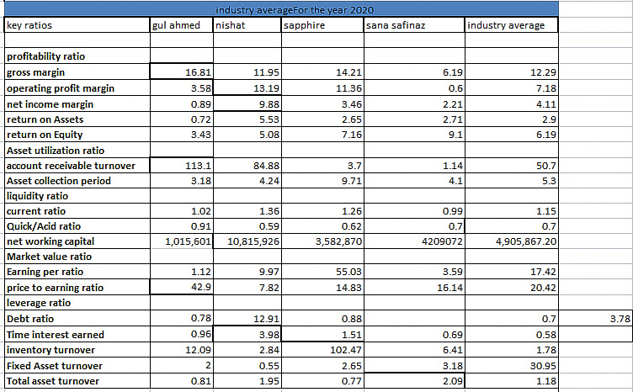

**Liquidity ratio:**

**Current** **ratio**:

The average current ratio is 1.15 which is high. Nishat and sapphire although they’re highly liquid, it also shows they’ve too much current assets that are to be utilized more efficiently. Rest of the companies have current ratio below the industry average which can be seen as in a good view as they don’t have extra current assets

**Quick/Acid ratio:**

The average quick/acid ratio is 0.70 which is high. All the competitors have a high quick ratio, which makes them highly liquid however; too much high ratio means too much use of current assets. As Sana safinaz tends to be highly liquid it also shows inefficiency in current assets.

* Net working capital:

The industry average is around 4905867.2. Nishat has the highest net working capital which means company has too much net working capital and isn’t managing its assets and liabilities efficiently; While Sana safinaz has the least net working capital.

Asset utilization ratios:

Account receivable turnover: the higher the receivable the more efficiently company is in collecting debts. And through the data we can analyse that Gul ahmed has the highest turnover of around 113.1 which means it is the most efficient when it comes to collecting debts. Nishat also has the good average as it is performing above the industry average. Rest of the firms including sana safinaz and sapphire are the least efficient in collecting debts as their receivables are far less than that of competitors they need to take a strict action towards credit control management

Asset collection period:

The lower the asset collection period, the faster the organization is when it comes to collecting payments. Sapphire has the highest Asset collection period which isn’t the good sign as they’re low in terms of collecting payments while the Gul Ahmed has the lowest collection period which means they’re the fastest to collect the payments. Rest of the firms should decide to grant more credit in order to increase the sales.

Leverage ratio:

* Debt ratio: Nishat has the best debt ratio while the rest of the firms are performing below the industry average ratio. Sana safinaz has the worst debt ratio
* Time interest earned: it shows how many times a firm can pay interest with its EBIT. The average time interest earned ratio is 1.78. Nishat has the highest time interest earned, which means that it can make payments 4 times from its EBIT. While rest of the firms have good time interest earned ratio but the benchmark shows that they’re performing below the industry average and need to take some steps. Sana safinaz has the lowest ratio so steps like increasing sales and reducing costs should take to remain competitive.

**Profitability ratio:**

* **Gross profit margin:**

The average gross profit margin is 12.29. Gul Ahmed has the best gross profit margin while Sana safinaz has the least one. Sapphire also has the ratio above the average industry ratio but Nishat and Sana safinaz need to improve their sales and reduces the cost of goods sold in order to reach average gross profit margin.

* **Operating** **profit** **margin**:

The average operating profit margin is 7.18. Only Nishat and sapphire have a good operating profit margin while rest of the firms are also performing good but has the ratio below the industry average. Among all of these the least one is Sana safinaz so it needs to take steps like either the operating expenses has to be reduced or sales has to be increased by these firms in order to reach on average operating margin

* **Net** **income** **margin**: the average net income margin is 4.11. Nishat has the highest ratio which indicates it’s highly profitable. While rest of the firms are performing below the industry average, Gul Ahmed is among the least one which means to take certain steps such as expense can be reduced or sales can be increase in order to reach on average net income margin.
* **Return on assets:**

It measures the Net profit before interest and taxes on every 1$ of asset. The average return on assets is 2.90. Nishat has the highest Return on assets which shows it had used its assets efficiently as compare to other competitors. Rest of the firms have performed below the industry average which means they need to take efficient decisions on how to use the assets in order to earn more profits and get a higher Return on assets.

* **Return on equity:**

The average return on equity is 6.19. Sana Safinaz has the best Return on equity which indicates its utilizing equity efficiently to generate profits as compare to other ones. Rest of the firms are also performing well except Gul Ahmed which has the least return on equity it has to take efficient decisions on how to use the equity in order to earn profits and get a higher return on equity.

**Market value ratio:**

* **Earnings per share ratio:**

Sapphire has the best earning per share ratio, all the ordinary shareholders are highly satisfied as their per sharing earnings of the company are far above the average earnings of the industry. While Nishat and Sana safinaz are performing below and Gul ahmed has the worst earning per share it has to take certain steps like improving sales and reducing expenses so that the firm can gets closer to the industry average.

* **Price to earnings ratio:**

The industry average of price to earnings ratio is 20.42. Gul Ahmed has the best price to earnings ratio while the Nishat has the worst one. This shows that Gul Ahmed is getting the great value from the market of its share as compared to its earnings while Nishat has the lowest price to earnings as compared to industry averages.

**Turnover ratios:**

* **Inventory turnover:**

The ratio shows the number of times a firm sells its inventory. The average turnover of this industry is 30.95. Sapphire has the highest inventory turnover which means it is the fastest in selling its inventories. While Gul Ahmed is performing below the average, Nishat and sana safinaz has the least turnover which means they need to improve their sales in order to reach on average industry turnover.

**Fixed asset turnover:**

This determines how fixed assets are used efficiently to generate revenue. Higher is better. The industry average of fixed asset turnover is 2.09. we can say sapphire is performing well above the average benchmark of the industry but Sana safinaz tends to be most efficiently utilizing its fixed assets to generate revenue with a turnover of 3.2 times.

**Total asset turnover:**

This determines how the company is utilizing its total assets to generate revenue. The average total asset turnover is 1.18.  Sana Safinaz is the most efficient in utilizing its total assets to generate revenue. Rest of firms are somewhere nearest the average benchmark of industry. Gul Ahmed and sapphire are the least efficient ones

**Industry Recommendation:**

Gul ahmed considered as one of the leading businesses doesn’t need any such recommendations but however textile industry seemed to perform slightly performed the lowest in 2020 as the pandemic affect their sales, export, import and profitability but which they’ve offset by overcoming the losses or profit by 2021. However they’re some other recommendations given below

* Keeping in view of current situation in which how people have lost their jobs and now the inflation is also at high level it might going to affect the sales in near future as of higher prices people could switch towards other competitors this could bring more losses to the company however reducing the prices over their some products which are highly expensive could result in boosting up their sales more but also they’ll be able to offset their liabilities which they’ve generate in year 2021.
* By bringing more innovations, adapting to latest technologies such as Cnc computered controlled network machine etc it’s most likely that Gul Ahmed could continue to prove to be a threat to many competitors out there.
* Apart from finance view, they should work on creating a healthier environment for their employees out there such as giving more incentives, not burdening the workers, providing ease on workload etc.

**Conclusion**:

Gul Ahmed is considered as one of the pioneers of textile industry of Pakistan. After doing a research just came to the conclusion that Gul Ahmed is performing well financially which could lead to attract more investors in near future. However there are some areas which they need to worked on I order to be on track in financial terms those areas have already been discussed in interpretation but Keeping all the things in mind Gul Ahmed’s growth is sustain and the company is financially healthy which means it’ll continued to be viable as a business.